**Project Profile :-**

|  |  |
| --- | --- |
| **Project Title** | **"Doccur"** |
| **Project Definition** | ‘Pharmacy distribution’ website basically contains :-  Pharmacy management system is designed to improve the accuracy, enhance safety and efficiency in the pharmaceutical store. It is a computer based system which helps the Pharmacist to improve inventory management, cost, medical safety etc.  Photo gallery facility |
| **Duration** | 3 Months |
| **Guided by** | Mr. Mayur Maroliya. |
| **Front End** | HTM, CSS, Boostrap, Javascript, Jquery, TailwindCSS |
| **Back End** | PHP, MYSQL |
| **Technologies Used** | AJAX |
| **Operating System** | Windows 10 [64 bits] [32 bits] |
| **Submitted By** | Rohit Jadhav []  Dushant Mali. [] |

**Abstract**

Nowadays, Pharmacy management system is one of the most essential tools that are mostly used in medical store; it is mostly used to manage pharmacy related activities

|  |  |  |  |  |
| --- | --- | --- | --- | --- |
| such as medical inventory, record keeping, sales management as well | | | as managing the drug | |
| Stock and information of the expired medicines. Many pharmacies | | |  | are still |
| operating | manually; | they don’t have adequate software to manage their | | Daily activities. It |
| needs the | pharmacist | assistant to check the expired date of the medicine twice a week, and it | | |
| can take a lot of time | | to find out whether certain medicine are out of stock. | |  |

In this project we tried to develop a computerised and web based Pharmacy management system. Our main intention is to allow this application to be used in most retailing pharmacies, where a small point of customization will be required to each pharmacy in the implementation period. This system is designed to overcome all challenges related to the management of medicine that were used to be handled locally and manually.

Pharmacy management system has its own significance to the retail pharmacy shops. Using this system, it will help us to records all transaction made at the daily sales, recognise all customers, employees, balance stock, etc. It will manage all activities around the shop that increases productivity and maximize profit, it will also minimizing the risk of getting loss because all transactions are recorded to the system.

**SUMMARY**

Pharmacy management system is designed to improve the accuracy, enhance safety and efficiency in the pharmaceutical store. It is a computer based system which helps the Pharmacist to improve inventory management, cost, medical safety etc.

Pharmacy management system was developed to ensure the security of information and reliability of Pharmacy records when accessing and providing services to the customers. The information gathered during the data collection was properly analysed and the results provided the basis for the new system. The system was tested and found to be functional and the outputs produced by this system were encouraging. The application will hence reduce the loss of information unlike the existing system and also information will be processed fast.

**TECHNOLOGY**

**SOFTWARE OR TOOLS**

The tools that I have used in developing this System is:-

* Sublime, Notepad++
* Xamppserver
* Adobe Photoshop
* Google chrome,Firefox,Internet Explorer
* Bootstrap Framework
* Microsoft word for project documentation
* JQuery
* HTML
* PHP
* MYSQL

**HARDWARE REQUIREMENTS**

1. Personzal computer with at least

* At least 4GB of RAM
* At least Hard disk (300GB, 500GB .etc.)
* At least Processor 2.7GHZ

1. Printer

**ABRIVIATIONS**

PHP- Hypertext Pre-processor (earlier called, Personal Home Page)

HTML- Hypertext Mark-up Language

DFD- Data flow Diagram

CSS- Cascading Style Sheets

SDLC- System Development life cycle

PMS-Pharmacy Management System

MYSQL- Michael “Monty” Structured Query Language

* 1. **Introduction**

This project concerned about developing a Pharmacy Management System that will be used for retail and wholesale pharmacies. The purpose of this project is to manage all data derived for a pharmacy to maintain their business through the system rather than recording their data manually which is more risk to the business to maintain and to avoid loss. According to my

Feasibility study of different pharmacies and recognized that most of them they recording their data manually through

Book of accounts. This type of recording data it makes them to incurred more loss and they are not able to determine if they incurred loss or not for those who having a large stock of medicine. There are a lot of discrepancies of items in the stock, it is hard for them even to recognise their all customer’s records; they cannot have even their weekly, monthly or a yearly report easily because of recording manually. Due to this challenges which cause to minimize a business profit I became with solution on how they can reduce risk and maximize their profit through Pharmacy management system.

**1.2 Background of the study**

Pharmacy management system is a system that consists of data entry, retrieval and monitoring stock, sale, customer records and management administrator’s records and determination of minimum quantity of each drug. String searching technique also applied in this system. This technique is referring by drugs name, drug code and description of drugs. Besides that, the system also provides two types of methods which are Quantity and Expire date of drugs.

Due to the size and quantity service of the pharmacy, the pharmacy has a very large customer base. The number of customers is quickly increases due to the increase of demand of drugs in many areas. This situation makes the pharmacist to be busy and use a lot of time to manage and control their business records. Meanwhile the pharmacist has to insure satisfaction in services to keep their records effectively at a reasonable time.

Pharmacy management deals with managing the medicine stock and selecting the suitable medicine needed by the customers. The core of pharmacist profession is the maintenance of quality and the subsequent implication for medical monitor and control in the pharmacy activities. The industry type of Pharmacy management system Medicine Selector for Pharmacy management System, or Doccur is medical technology industry. The domain of this project is information Technology in healthcare. Within the growth of the information Communication Technology and Medical Technology, the system developers take this opportunity to help the pharmacist to manage stocks and select the medicine using computer program. Doccur is developed to select the medicine for managing all of the medicine in pharmacy and other activities related with a pharmacy. This system also managing the selling process, customer records, and users’ records.

The module involve are medicine management module, medicine search module, selling process module, medicine list module, statistic of medicine sales module, date to date report module, and other Reports.

1.3 **Problem statement**

Improving performance and efficiency in pharmacy shops is a major goal of Pharmacy Management System. The transaction related to sales, maintaining of stocks records are maintained manually at present. These are to be automated and an application is required to relate of them relatively and logically so that the current system can be replaced and accepted without major changes and problems. The application will provide quick access to the records maintained and must reveal the important reviews about the business so that the growth can be easily compared and will provide with the various reports showing the related details that the important decisions could be taken easily.

The following are among of the problems that lead to propose creation and development of Pharmacy Management System Software.

* There is no effectively management of information
* Discrepancies of stock items.
* It hard to determine stock balance.
* Hard and Time consuming on preparation of daily, weekly, monthly, and yearly reports.

1.4 **Objective of the project**

The overall objective of this project is to establish a System for pharmacy shops so as to improve the performance and efficiency of pharmacy shops management. In order to achieve this goal effectively, there are some specific objectives should be implemented;

The following are specific objectives for this project.

* To provide easily accessibility of customers management
* To provide easily accessibility of sales reports
* To provide easily accessibility of stock reports
* To provide accessibility of debtors registration and review all your debtors
* To provide easily accessibility of Employees records etc.
* To provide easily accessibility of printing and prepare invoices for customers
* Printing of customers, debtors, and employees, sales, Purchases and all inventory reports.
* To minimise human errors.
* To provide optimal drugs inventory management by monitoring the drugs’ movement in the pharmacy unit.

1.5 **Significance of the study**

Pharmacy management system has its own significance to the pharmacy shops. Using this system, help to records all transaction made at the daily sales, it help to recognise all debtors, customers, employees, balance stock, etc. It manage all activities around the shop that increases productivity and maximize profit because a system is minimizing the risk of getting loss because all transaction recorded to the system and viewed if needed and the whole reports of the business will be shown at any time needed to be done.

**1.6 Scope**

The user of this system is being able to manage all necessary activities of the pharmacy shop. The information management that provided by the system is a great advantage to reduce records errors associated with pharmacy shops.

The system is handling all aspects of the inventory control function. It allow the Administrator, delete obsolete drugs and modify the current dosage and indications of a drug in the database.

Furthermore, the system will make the process of stock replenishment to be easily.

On the other hand, Doccur is able to generate reports on the list of drugs in the stock for a given period of time. Also a system allow to know the expire date of drugs from early expire date to late expired in the stock. Although a Pharmacist is not able to delete, or update any items to database because he/she has no authority to do so, even to view or print any report, but the system allow him/her to sale and to see which items sold at the time.

Pharmacy Management System covered the following areas.

* Pharmacist management
* Sales management
* Stock management
* And reports management

**Literature review**

The main goal of Pharmacy management system is to manage all records and transaction within the inventory and managing of sales. Pharmacy management System is a very effective tool for an organization to be efficient in business management. The traditional way of managing sales and inventory is performed by using a pen and a paper to write down the type and quantity of the stock. But errors in inventory records still exist even when the management uses IT systems and product data capturing technologies to improve the inventory systems. Inventory managers have to face inaccuracy of inventory records either at the store or at the warehouse level.

2.1 **Theoretical review.**

Pharmacy Management system is a web base system that works as a website to manage and functioning all pharmacy activities through a web server (Apache). A web page is what you see on the screen when you type in a web address, click on a link, or put a query in a search engine. A web page can contain any type of information, and can include text, colour, graphics, animation and sound.

When someone gives you their web address, it generally takes you to their website's home page, which should introduce you to what that site offers in terms of information or other services. From the home page, you can click on links to reach other sections of the site. A website can consist of one page, or of tens of thousands of pages, depending on what the site owner is trying to accomplish.

2.2 **EMPARICAL REVIEW**

Over the past 40 years, information technology has had a major impact on the working lives of millions of people. Many industries have embraced computer technology because of the benefits of automated information processing. These include enabling routine, repetitive and monotonous tasks to be conducted with consistent accuracy; standardisation and consistent use of terminology and nomenclature; and mass customisation (the capacity of information

Technology to provide services to a large population, yet in a way that can be customised to the individual).

For prescribers and pharmacists, IT can enable the storage of structured sales records, facilitate the electronic prescribing, customers and management of medicines, automate the handling of medicines in the supply chain and provide tools for monitoring the efficacy and safety of medicines in the inventory. IT can therefore improve pharmacy management, enable professionals to provide high quality services and help to provide accuracy data through the system that will be able to handle all necessary activities in the pharmacy E.g. sales and stock reports.

**2.3** **Feasibility Study**

A feasibility analysis involves a detailed assessment of the need, value and practicality of a proposed enterprise, such as systems development. The process of designing and implementing record keeping systems has significant accountability and resource implications for an organization. Feasibility analysis will help you make informed and transparent decisions at crucial points during the developmental process to determine whether it is operationally, economically and technically realistic to proceed with a particular course of action.

Most feasibility studies are distinguished for both users and analysts. First, the study often presupposes that when the feasibility document is being prepared, the analyst is in a position to evaluate solutions. Second, most studies tend to overlook the confusion inherent in system development – the constraints and the assumed attitudes.

**2.3.1 Operational feasibility**

People are inherently resistant to change, and computers have been known to facilitate change. An estimate should be made of how strong a reaction the user staff is likely to have toward the development of a computerized system. It is common knowledge that computer installations have something to do with turnover, transfers, retraining, and changes in employee job status. Therefore, it is understood that the introduction of a candidate system requires special effort to educate, sell and train the staff on new ways of conducting business.

**2.3.2** **Technical feasibility**

Technical feasibility centres around the existing computer system (hardware, software, etc.) and to what extend it can support the proposed addition. For example, if the current computer is operating at 80 per cent capacity – an arbitrary ceiling – then running another application could overload the system or require additional hardware. This involves financial considerations to accommodate technical enhancements. If the budget is a serious constraint, then the project is judged not feasible.

**2.3.3** **Cost/Benefit Analysis**

Economic analysis is the most frequently used method for evaluating the effectiveness of a candidate system. More commonly known as cost benefit analysis, the procedure is to determine the benefits and savings that are expected from a candidate system and compare them with costs. If benefits overweigh costs, then the decision is made to design and implement the system. Otherwise, further justification or alterations in the proposed system will have to be made if it is to have a chance of being approved. This is an on-going effort that improves in accuracy at each phase in the system life cycle.

**Methodology**

A methodology is the combination of logically related methods and step by step techniques for successful planning, control and delivery of the project. It is a scientifically-proven, systematic and disciplined approach to project development and implementation.

Approach that will be used in System Development.

In this project I have used System Development Life Cycle (SDLC) Methodology. System Development life cycle (SDLC) is a traditional methodology for developing maintaining and replacing information system. This methodology consists of different phases that describe the procedures for successful system development.

* Planning
* Analysis
* Design
* Implementation and
* And Maintenance

**3.2** **Planning**

It is the process of identifying problems, opportunities, and objectives. This phase required the analysts to look honestly at what is occurring in a business. Then, together with other organizational members, the analyst pinpoints problems. Identifying objectives is also an important component of the first phase. The analyst first discovered what the business is trying to do. Then the analyst was able to see whether some aspect of information systems applications can help the business reach its objectives by addressing specific problems or opportunities.

**Activities in this phase consist of**

* interviewing user management
* Summarizing the knowledge obtained
* Estimating the scope of the project and
* Documenting the results

The output of this phase is a feasibility report containing a problem definition and summarizing the objectives. Management must then make a decision on whether to proceed with the proposed project

3.3 **System Analysis**

It is a process of collecting factual data, understand the processes involved, identifying problems and recommending feasible suggestions for improving the system functioning. This involves studying the business processes, gathering operational data, understand the information flow, finding out bottlenecks and evolving solutions for overcoming the weaknesses of the system so as to achieve the organizational goals. System Analysis also includes subdividing of complex process involving the entire system, identification of data store and manual processes.

3.4 **System Design**

It is the most crucial phase in the developments of a system. The logical system design arrived at as a result of systems analysis is converted into physical system design. Normally, the design proceeds in two stages:

3.5 **Preliminary or General Design:**

In the preliminary or general design, the features of the new system are specified. The costs of implementing these features and the benefits to be derived are estimated. If the project is still considered to be feasible, we move to the detailed design stage.

3.6 **Structured or Detailed Design:**

In the detailed design stage, computer oriented work begins in earliest. At this stage, the design of the system becomes more structured. Structure design is a blue print of a computer system solution to a given problem having the same components and inter-relationships among the same components as the original problem. There are several tools and techniques used for describing the system design of the system.

These tools and techniques are:

* Flowchart
* Data flow diagram (DFD)
* Data dictionary
* Structured English
* Decision table
* Decision tree

**The system design involved:**

* Defining precisely the required system output
* Determining the data requirement for producing the output
* Determining the medium and format of files and databases
* Devising processing methods and use of software to produce output
* Determine the methods of data capture and data input
* Designing Input forms
* Designing Codification Schemes
* Detailed manual procedures
* Documenting the Design

3.7 **Implementation**

After having the user acceptance of the new system which has developed, the implementation phase began. Implementation is the stage of a project during which theory is turned into practice. The major steps involved in this phase are:

3.8 **Coding**

The system design needed to be implemented to make it a workable system. This demands the coding of design into computer understandable language example programming language. This is also called the programming phase in which the programmer converts the program specifications into computer instructions, which we refer to as programs. It is an important stage where the defined procedures are transformed into control specifications by the help of a computer language.

3.9 **Testing**

Before actually implementing the new system into operation, a test run of the system has done for removing the bugs, if any. It is an important phase of a successful system. After codifying the whole programs of the system, a test plan should be developed and run on a given set of test data. The output of the test run should match the expected results. Sometimes, system testing is using the test data following test run are carried out:

3.10 **Program test**

When the programs coded, compiled and brought to working conditions, it was individually tested with the prepared test data. Any undesirable happening has been noted and debugged (error corrections)

3.11 **System Test**

After carrying out the program test for each of the programs of the system and errors removed, then system test has done. At this stage the test has been done on actual data. The completed system has been executed on the actual data. At each stage of the execution, the results or output of the system was analysed. During the result analysis, was found that the outputs are not matching the expected output of the system. In such case, the errors in the particular programs has identified and fixed and further tested for the expected output.

3.12 **Maintenance**

It is necessary to eliminate errors in the system during its working life and to tune the system to any variations in its working environments. It has been seen that there are always some errors found in the systems that has noted and corrected.

It also means the review of the system from time to time. The review of the system is done for:

* Knowing the full capabilities of the system
* Knowing the required changes or the additional requirements

3.13 **Studying the performance**

If a major change to a system has been needed, a new project was being sated to carry out the change. The new project has been preceded through all the above life cycle phases.

3.14 **Targeted participants.**

The system target for the special management of pharmacy activities that able to manage stocks, sales, customers, and reports. The system helps to handle pharmacy activities and to improve efficiency of works and to reduce risks in discrepancies of items in the stock. Administrator, managers, and stock managers are able to delete, review, update, and add all items in the database, and printing of reports needed.

**4.1 Information gathering techniques**

Managing information involves gathering and distributing necessary information and assimilating them on the project management activities and processes. The information gathering techniques are repeated processes that are used to create and organize data across different kinds of sources. One of information gathering techniques I have used is:

[**Brainstorming:**](https://project-management-knowledge.com/definitions/b/brainstorming-technique/)

I have used method to get an idea of this project. All ideas are generated with the help of a facilitator through an open discussion and mass interviewing techniques. Commonly, the brainstorming technique has been conducted during a scheduled meeting with peers, individual brainstorming, and even at an informal meeting.

**4.2 Functional requirement**

There are functions done by the system such as: the necessary information of drugs, prepare profit and loss statement, customer records, debtors records, preparing of invoices, Calendar, sales records, stock management, gives daily reports, easily searching of medicine, Update, delete and printing all reports within the system.

**4.3 Non-Functional Requirements**

Pharmacy Management system is able to operate in the following characteristics.

* Any familiar in using windows operation can operate the system since it have user friendly and easy to use user interface.
* Reliability: The pharmacy system is available based on the user needs, can work properly and do transactions efficiently including safe management of the pharmacy.

The pharmacy system is password protected to change things on the system. Here the pharmacist Manager control over the system by login to the pharmacy system. Any user cannot use the system without registered by the Administrator and all result data is protected and controlled by the Administrator.

**5.1 Information gathering techniques**

Managing information involves gathering and distributing necessary information and assimilating them on the project management activities and processes. The information gathering techniques are repeated processes that are used to create and organize data across different kinds of sources. One of information gathering techniques I have used is:

[**Brainstorming:**](https://project-management-knowledge.com/definitions/b/brainstorming-technique/)

I have used method to get an idea of this project. All ideas are generated with the help of a facilitator through an open discussion and mass interviewing techniques. Commonly, the brainstorming technique has been conducted during a scheduled meeting with peers, individual brainstorming, and even at an informal meeting.

**5.2 Functional requirement**

There are functions done by the system such as: the necessary information of drugs, prepare profit and loss statement, customer records, debtors records, preparing of invoices, Calendar, sales records, stock management, gives daily reports, easily searching of medicine, Update, delete and printing all reports within the system.

**5.3 Non-Functional Requirements**

Pharmacy Management system is able to operate in the following characteristics.

* Any familiar in using windows operation can operate the system since it have user friendly and easy to use user interface.
* Reliability: The pharmacy system is available based on the user needs, can work properly and do transactions efficiently including safe management of the pharmacy.

The pharmacy system is password protected to change things on the system. Here the pharmacist Manager control over the system by login to the pharmacy system. Any user cannot use the system without registered by the Administrator and all result data is protected and controlled by the Administrator.

**SYSTEM DESIGN**

**6.1 Unified Modeling Language Diagrams(UML):**

* + The unified modeling language allows the software engineer to express an analysis model using the modeling notation that is governed by a set of syntactic semantic and pragmatic rules.
  + A UML system is represented using five different views that describe the system from distinctly different perspective. Each view is defined by a set of diagram, which is as follows.

**User Model View**

* + 1. This view represents the system from the users perspective.
    2. The analysis representation describes a usage scenario from the end-users perspective**.**

**Structural model view**

◆In this model the data and functionality are arrived from inside the system.

◆ This model view models the static structures.

**Behavioral Model View**

◆ It represents the dynamic of behavioral as parts of the system, depicting the interactions of collection between various structural elements described in the user model and structural model view.

**Implementation Model View**

* + In this the structural and behavioral as parts of the system are represented as they are to be built.

**Environmental Model View**

In this the structural and behavioral aspects of the environment in which the system is to be implemented are represented.

UML is specifically constructed through two different domains they are

* + UML Analysis modeling, which focuses on the user model and structural model views of the system?
  + UML design modeling, which focuses on the behavioral modeling, implementation modeling and environmental model views**.**

**Use Case flow Diagram (Pharmacist)**

**Pharmacist**

**Use Case flow Diagram (Admin)**

**Admin**

#### 6.2 ENTITY-RELATIONSHIP Diagrams

E-R (Entity-Relationship) Diagram is used to represents the relationship between entities in the table.

The symbols used in E-R diagrams are:

SYMBOL PURPOSE

Represents Entity sets.

Represent attributes.

Represent Relationship Sets.

Line represents flow

Structured analysis is a set of tools and techniques that the analyst.

To develop a new kind of a system:

The traditional approach focuses on the cost benefit and feasibility analysis, Project management, and hardware and software selection a personal considerations.

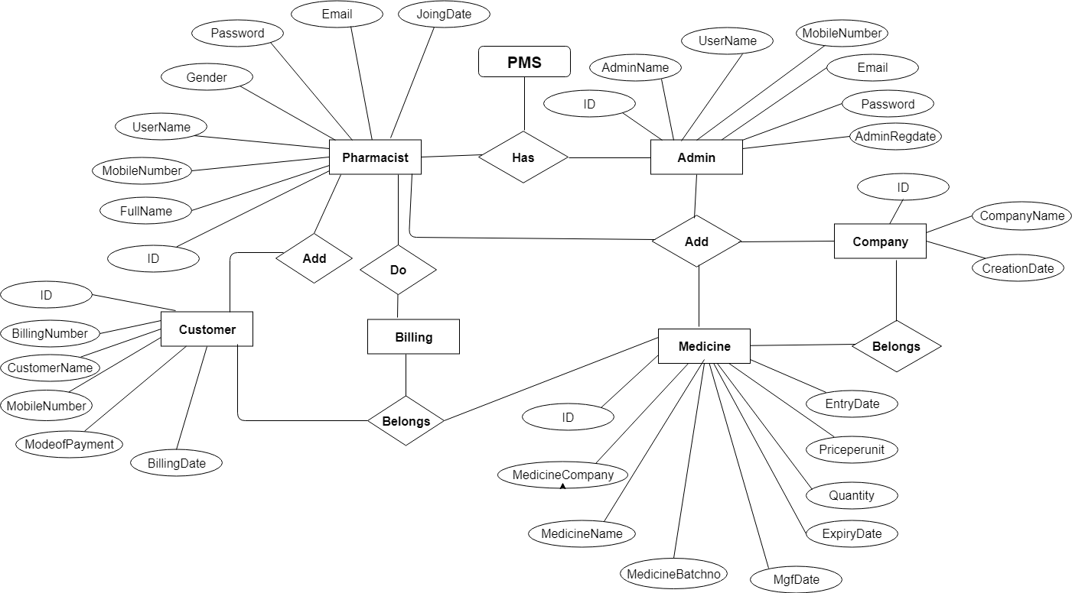

**7.1 Database implementation**

MYSQL- MySQL ("My S-Q-L", officially, but also called "My Sequel") is (as of July 2013) the world's second most widely used open-source relational database management system (RDBMS). It is named after co-founder Michael Widenius daughter, My. The SQL phrase stands for Structured Query Language. The MySQL development project has made its source code available under the terms of the GNU General Public License, as well as under a variety of proprietary agreements. MySQL was owned and sponsored by a single for-profit firm, the Swedish company MySQL AB, now owned by Oracle Corporation .MySQL is a popular choice of database for use in web applications, and is a central component of the widely used LAMP opens source web application software stack (and other 'AMP' stacks). LAMP is an acronym for "Linux, Apache, MySQL, Perl/PHP/Python." Free-software-open source projects that require a full-featured database management system often use MySQL. For commercial use, several paid editions are available, and offer additional functionality. Applications which use MySQL databases Library Management System include: TYPO3, MODx, Joomla, WordPress, phpBB, MyBB, Drupal and other software. MySQL is also used in many high-profile, large-scale websites, including Wikipedia, Google (though not for searches), Facebook, Twitter, Flickr, and YouTube.

**Database tables**

In this project various tables used for maintain the information.

[**tbladmin**](http://localhost/phpmyadmin/sql.php?db=camsdb&token=0cdfa1f46252d35aec9fa851dd4c03bb&goto=db_structure.php&table=tbladmin&pos=0) **:** This table use to store admin login details.

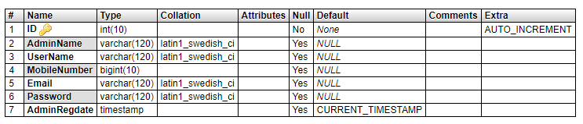

**tblcompany :** This table use to store medicine company details.

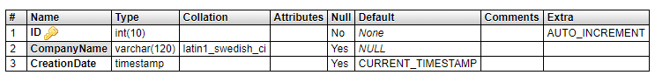

**tblmedicine :** This table use to store medicine details.

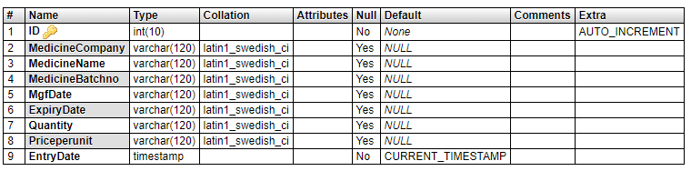

**tblpharmacist:** This table use to store pharmacist login details.

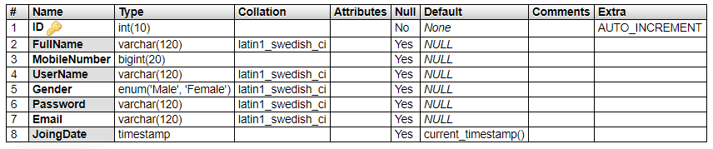

**tblcart:** This table use to store billing medicine details.

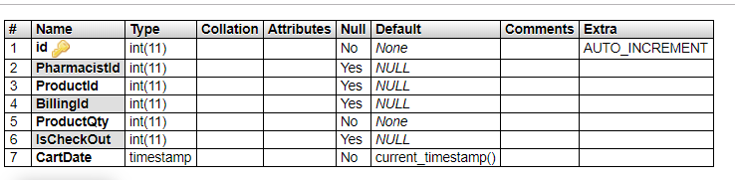

**tblcustomer:** This table use to store customer and final billing details.

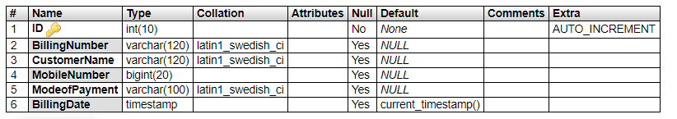

**7.2 Class Diagram:**

The class diagram shows a set of classes, interfaces, collaborations and their relationships.

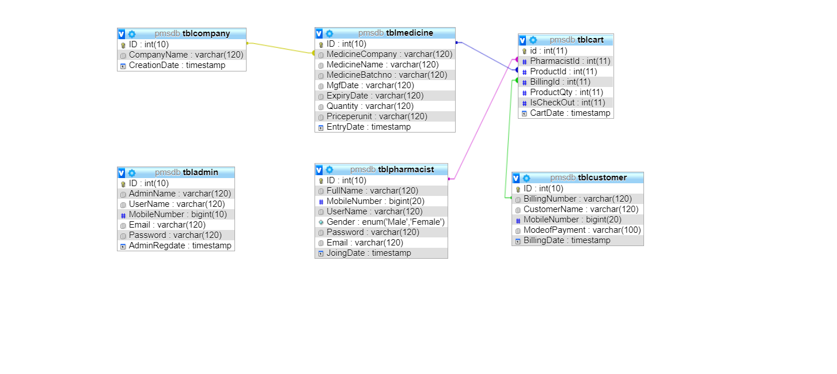

**Output Screen of Project**

**Home Page**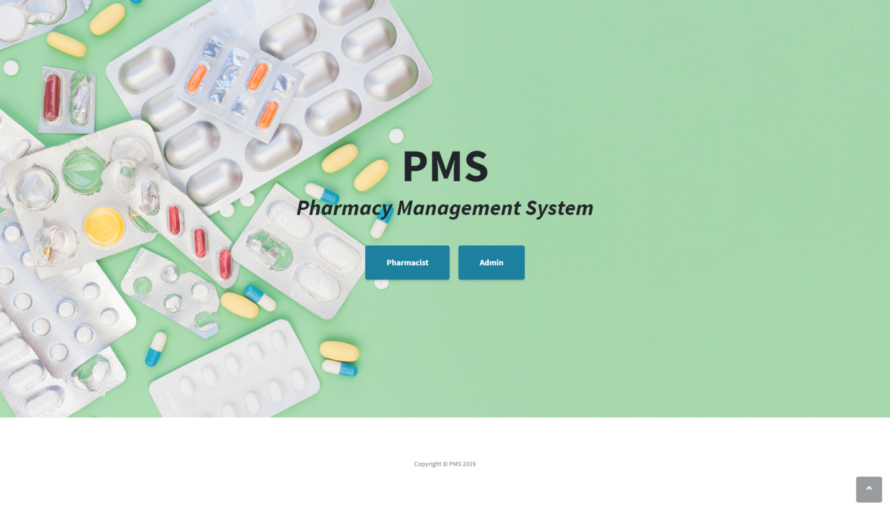

**8.1 Admin Module**

**Admin Login**

**Dashboard**

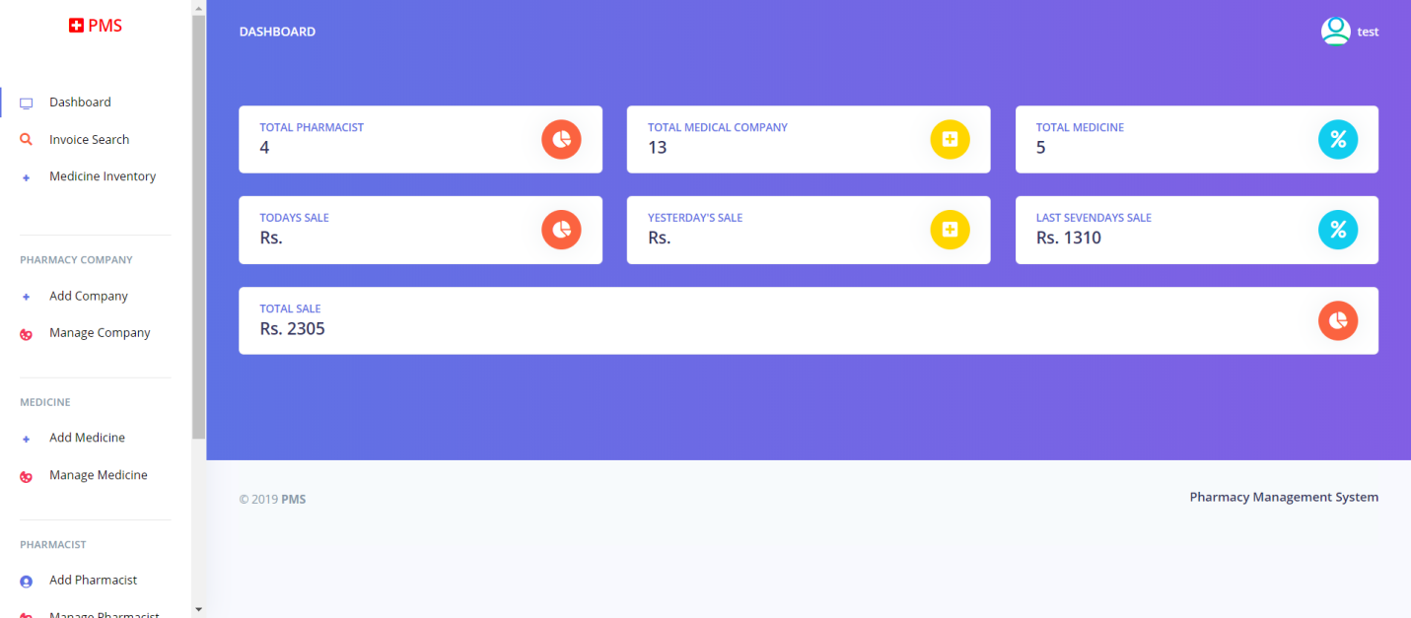

**Search Invoice**

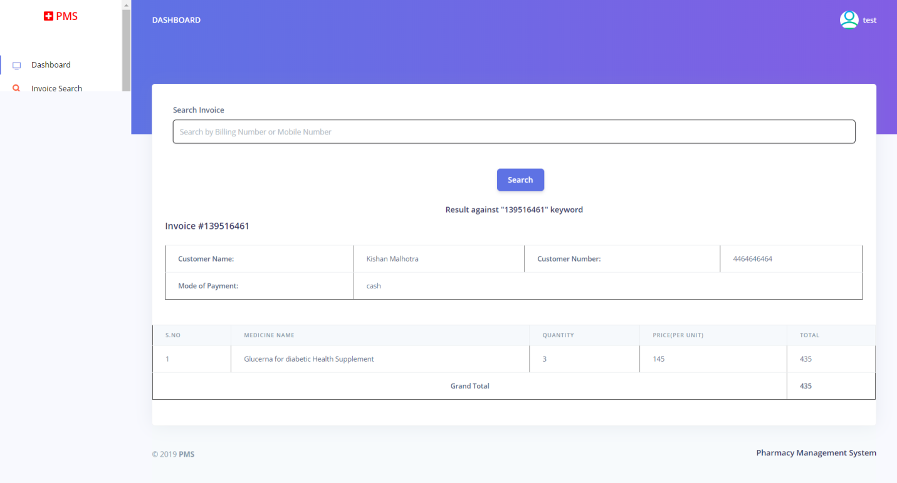

**Medicine Inventory**

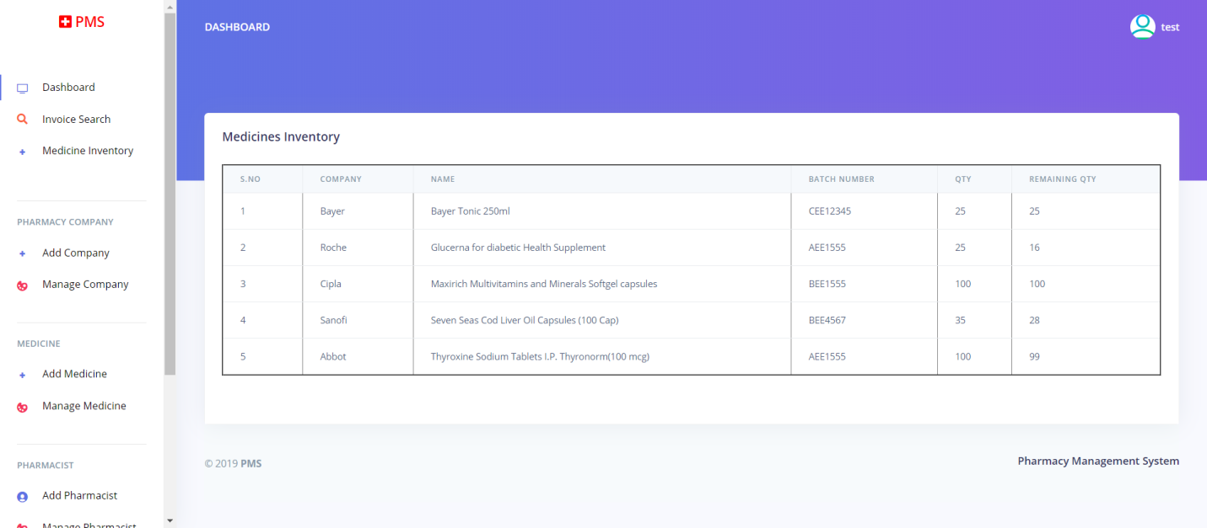

**Add Pharmacy Company**

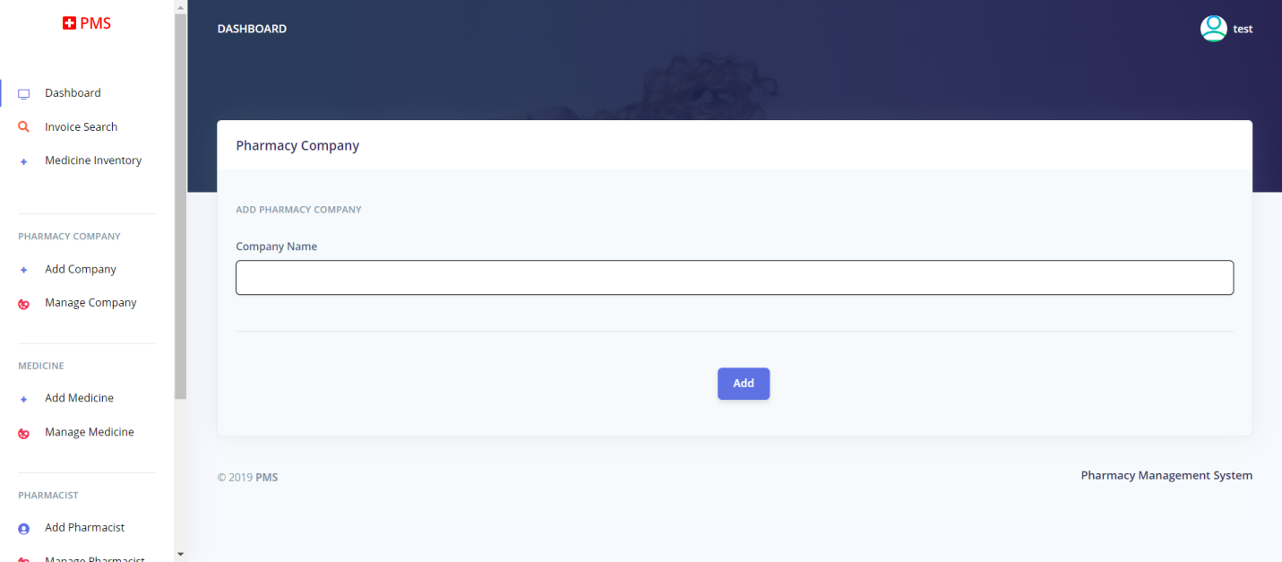

**Manage Pharmacy Company**

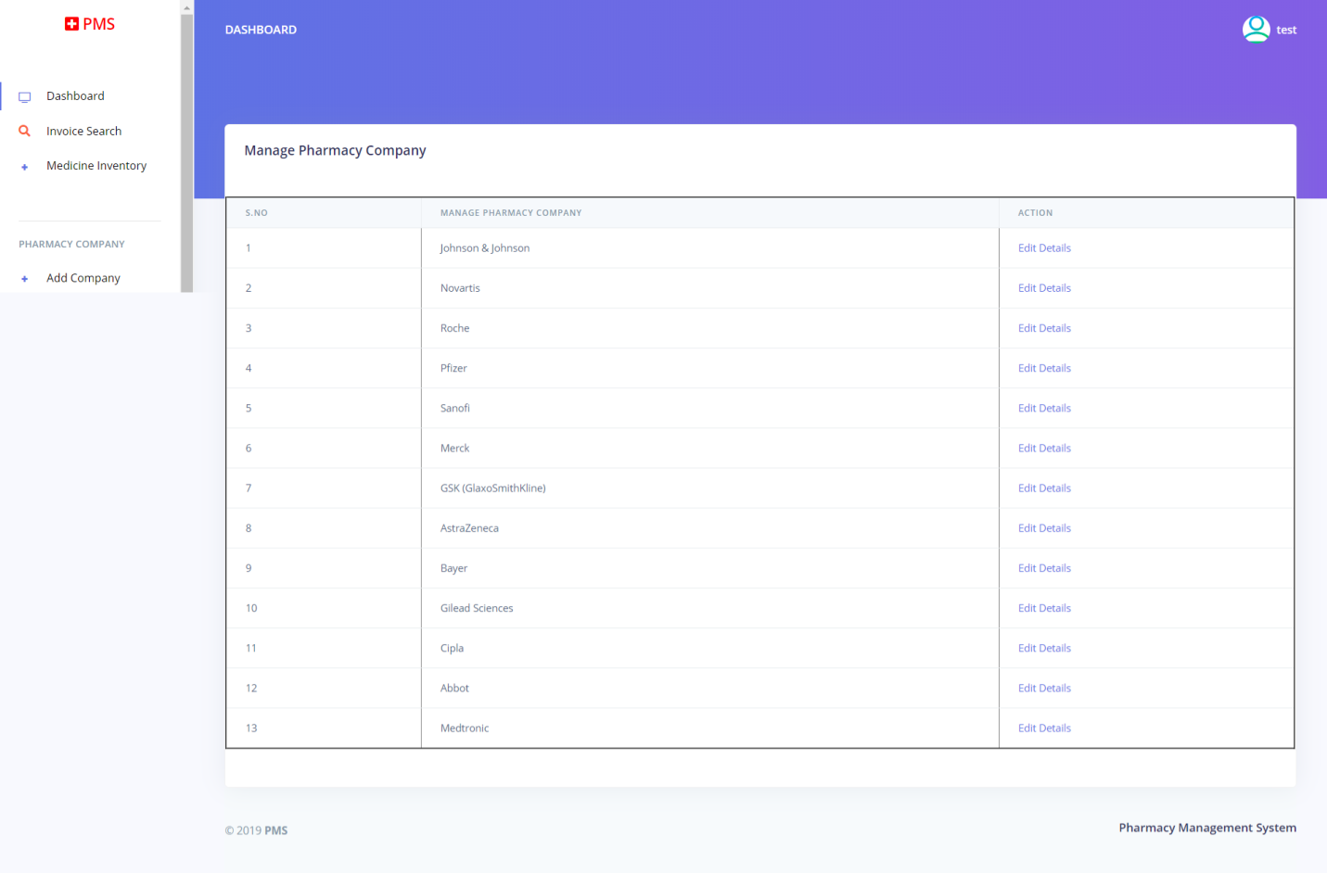

**Edit Pharmacy Company**

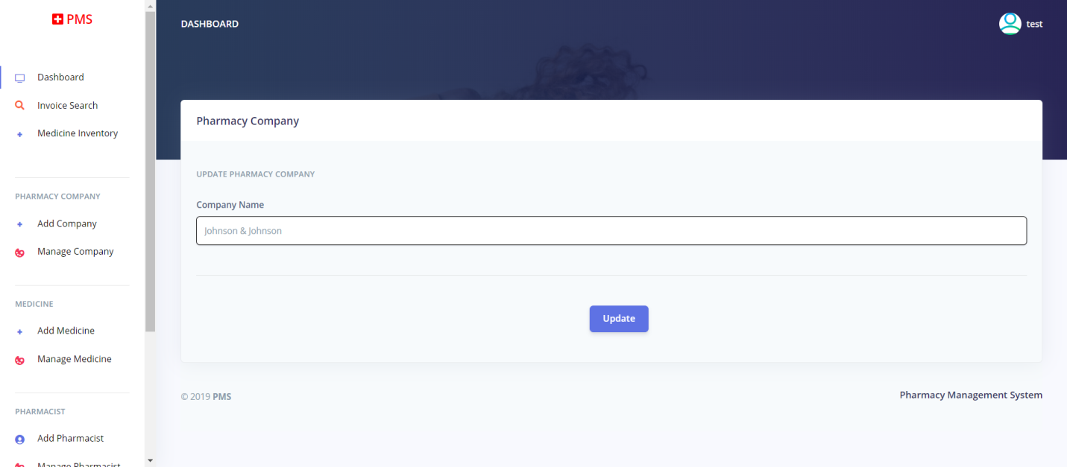

**Add medicine**

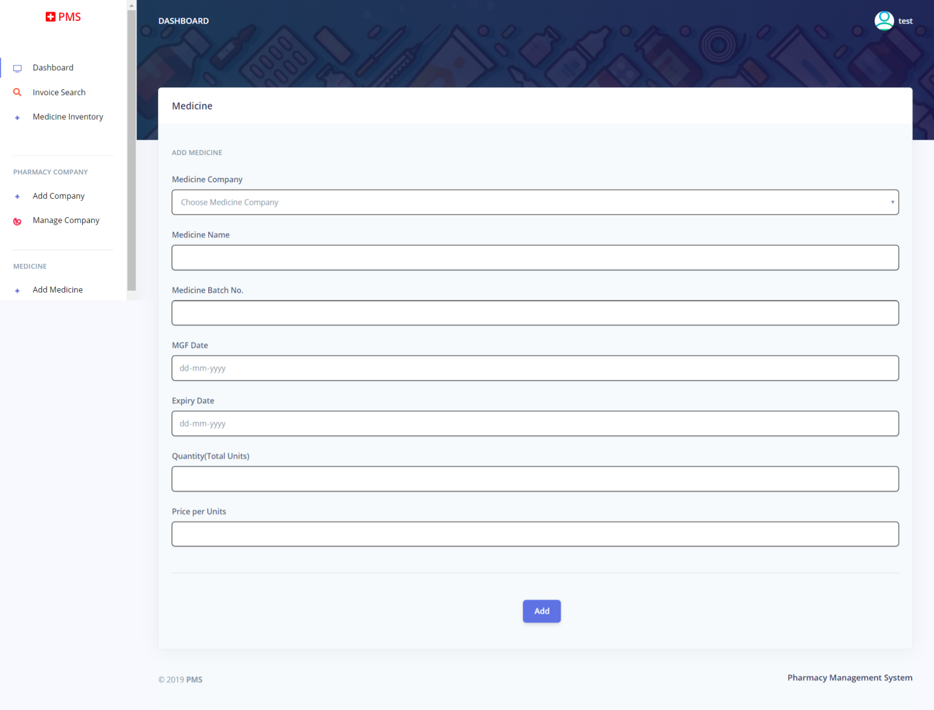

**Manage Medicine**

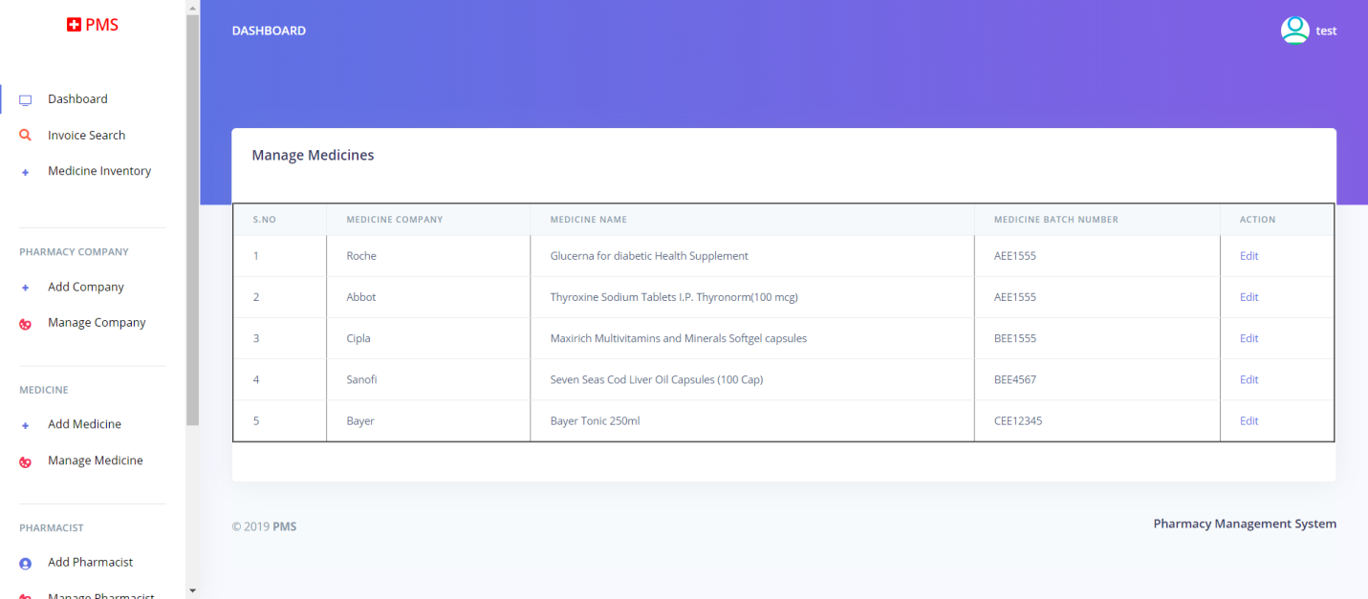

**Edit Medicine**

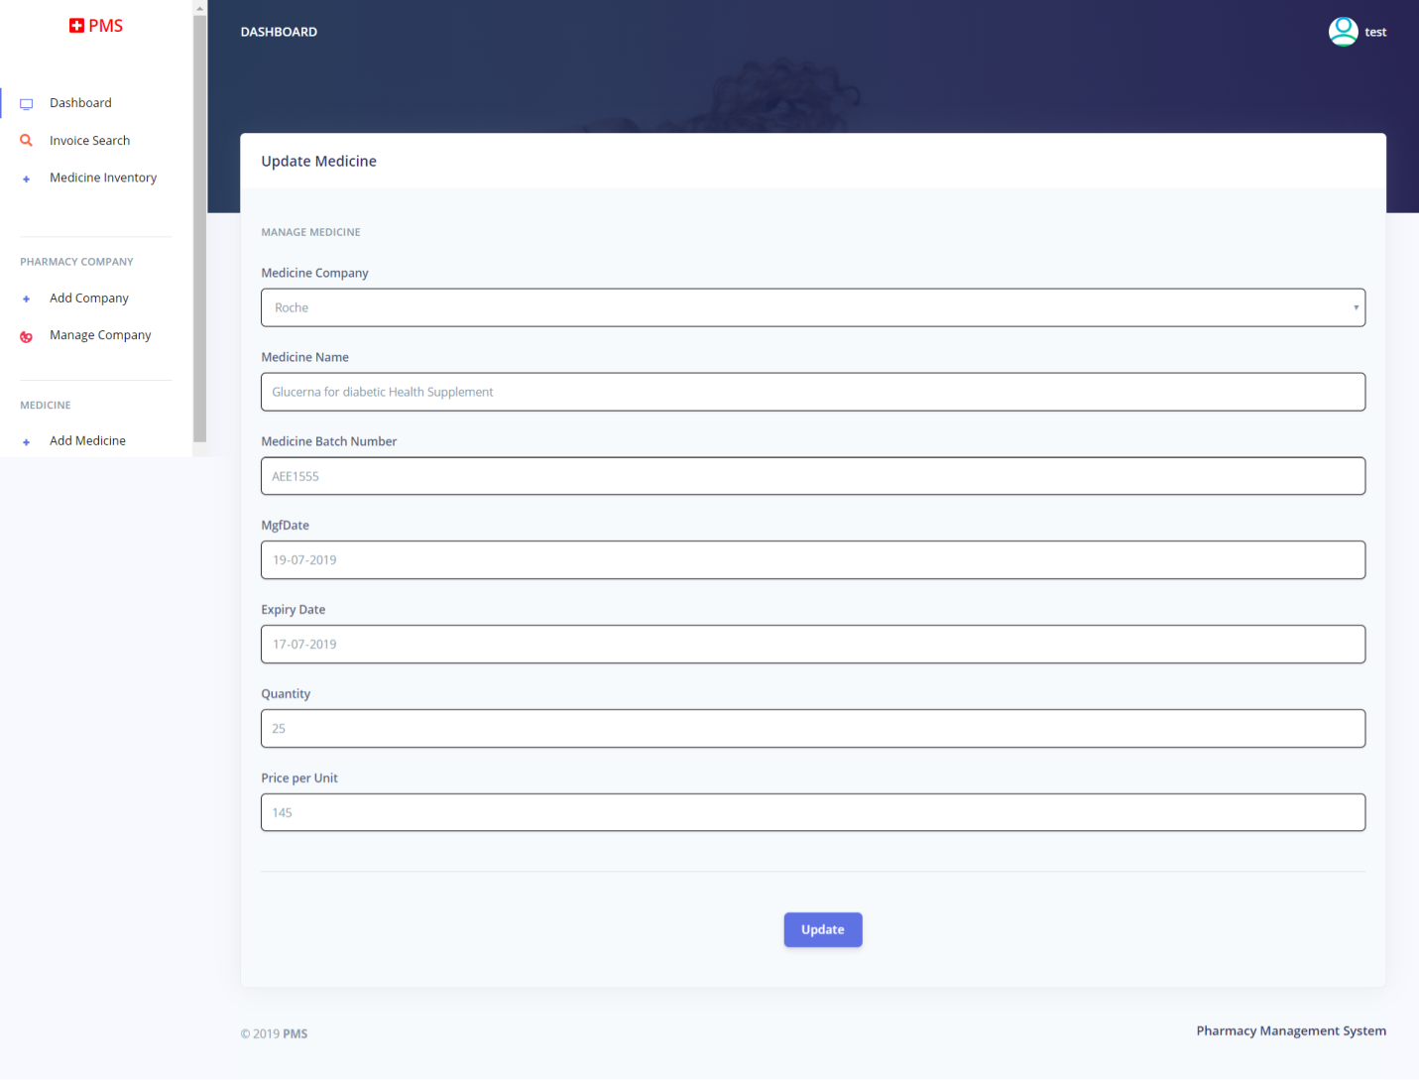

**Add Pharmacist**

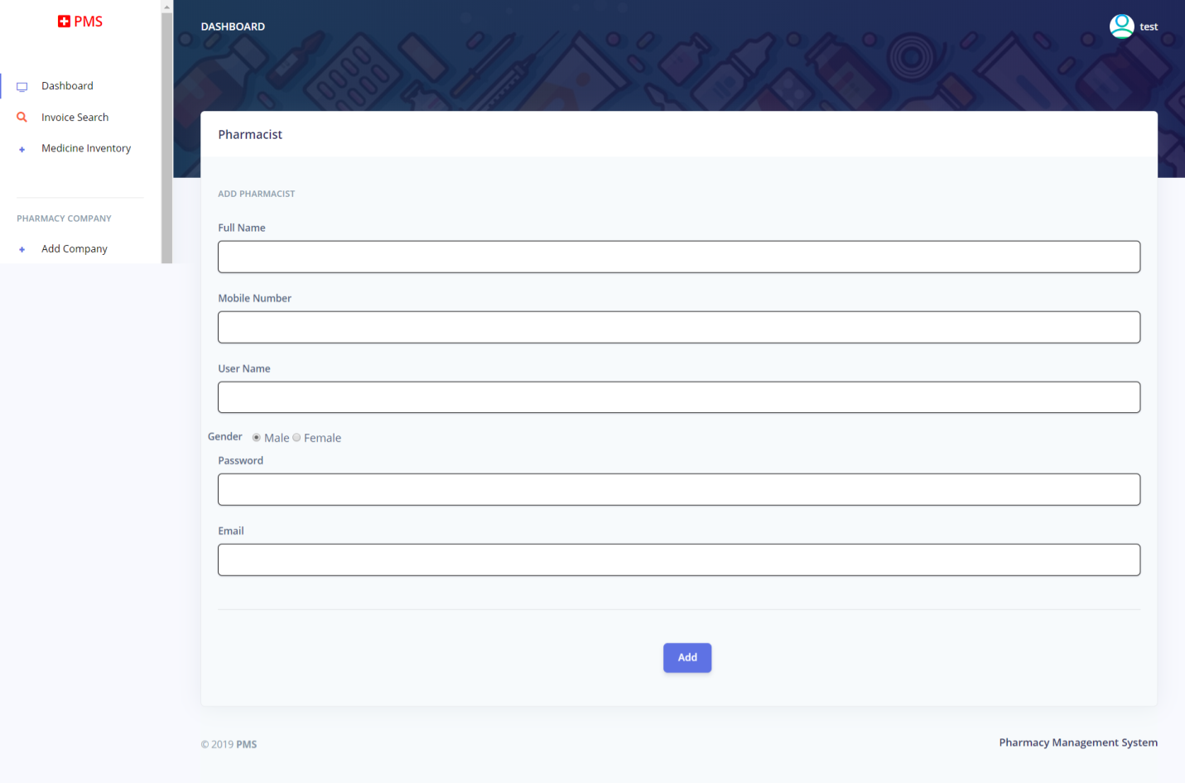

**Manage Pharmacist**

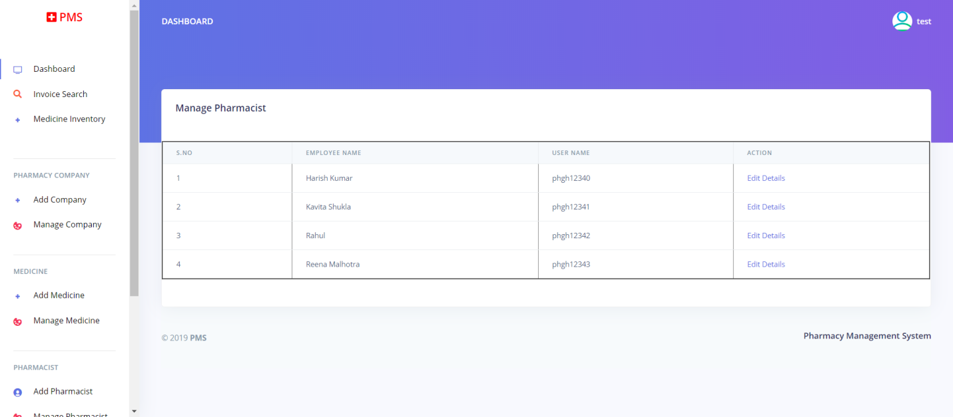

**Edit Pharmacist**

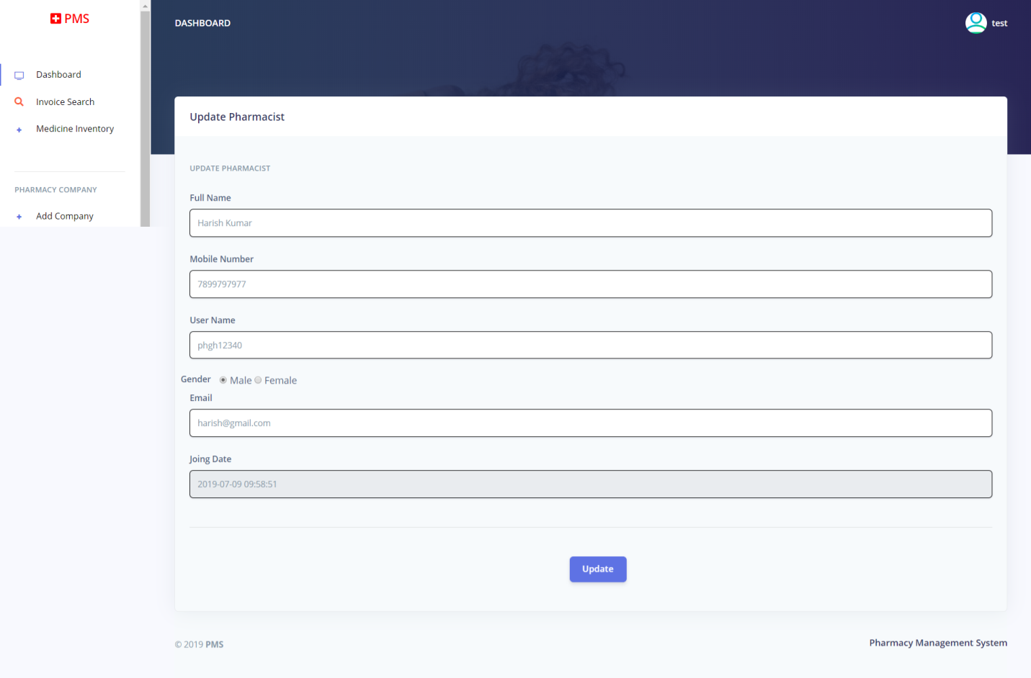

**Stock Reports**

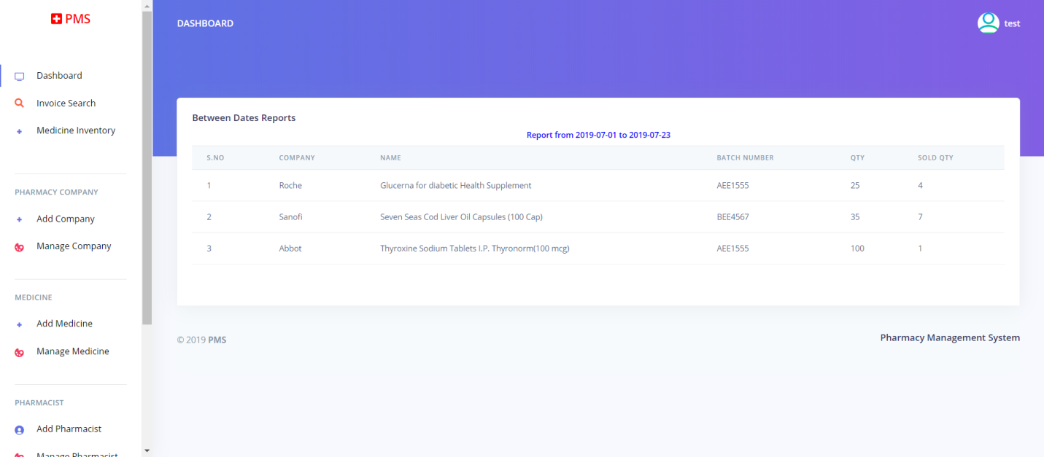

**Pharmacist wise sold report**

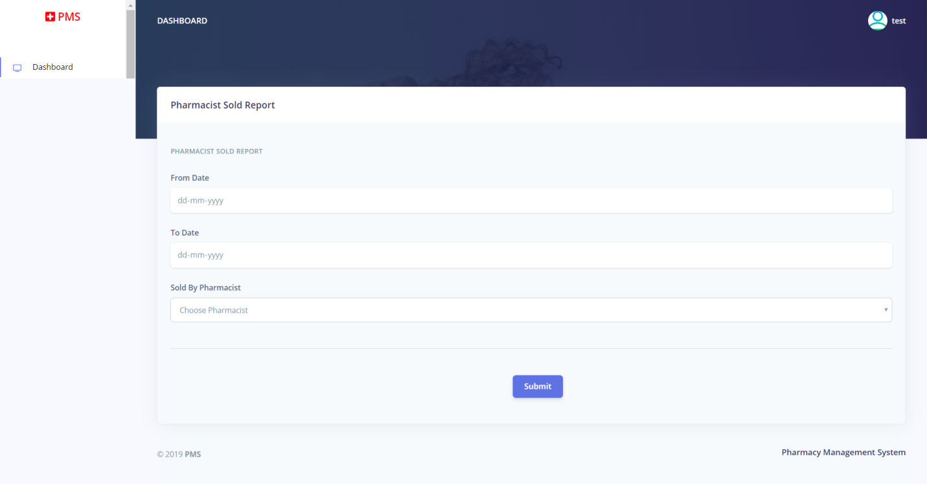

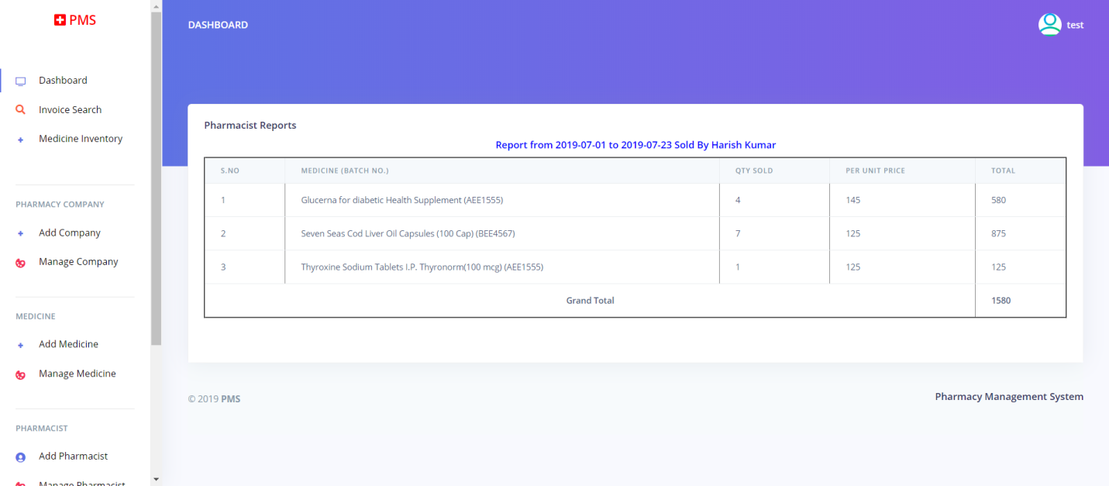

**Sales Report**

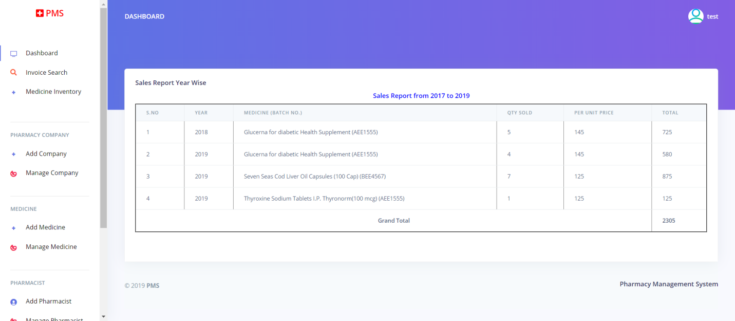

**Admin Profile**

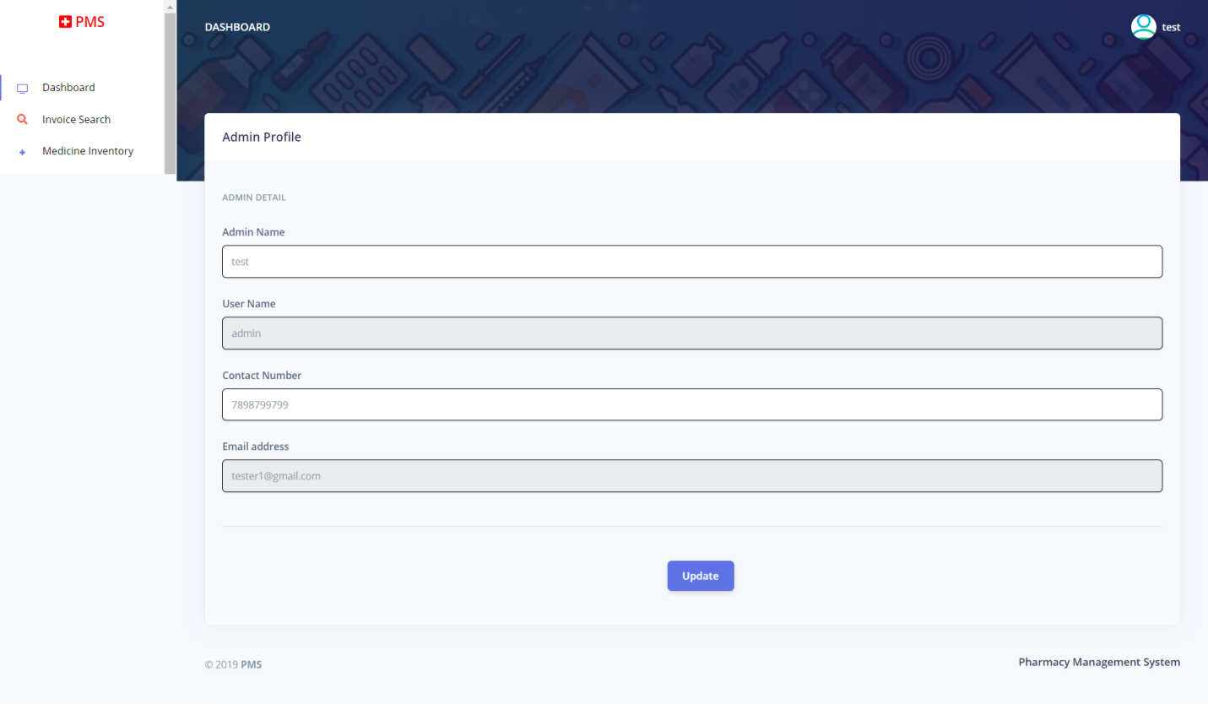

**Change Password**

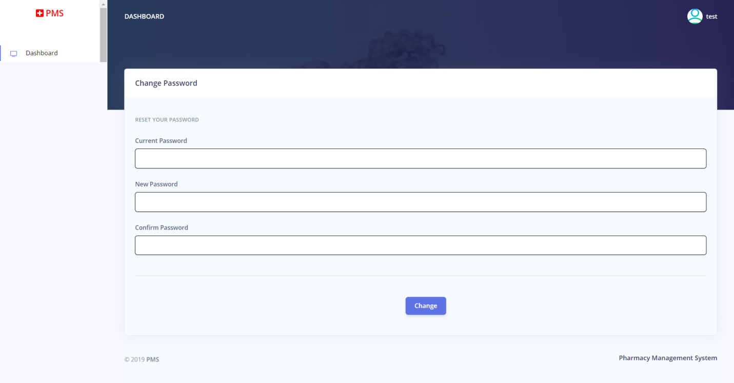

**Forgot password**



**Reset Password**



**8.2 Pharmacist**

**Login Page**



**Dashboard**

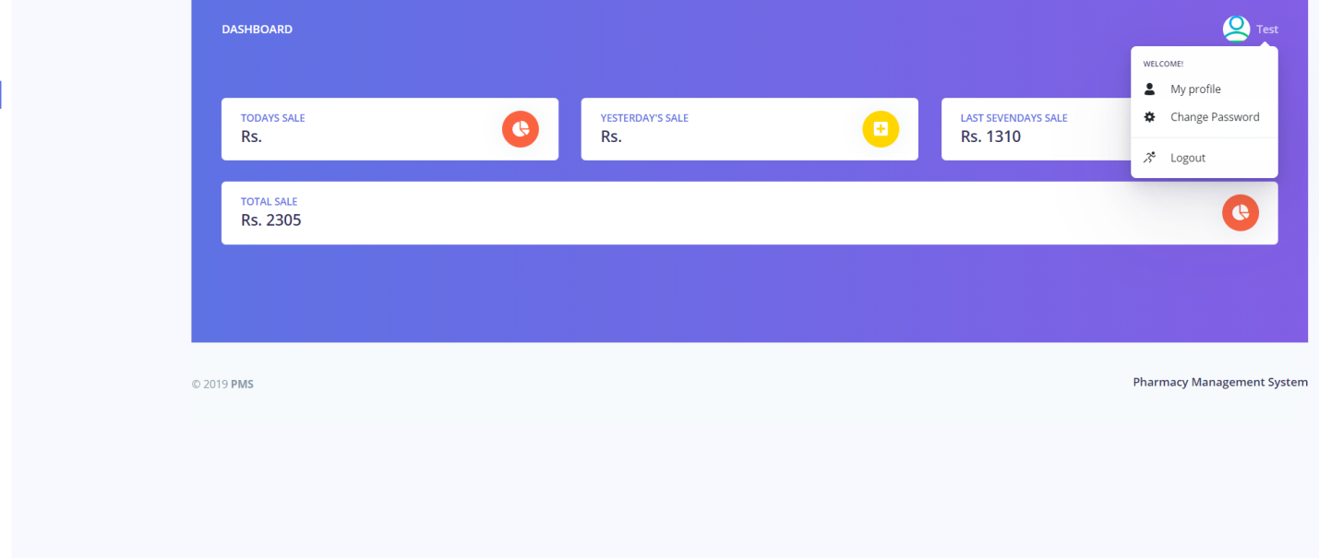

**Inventory**

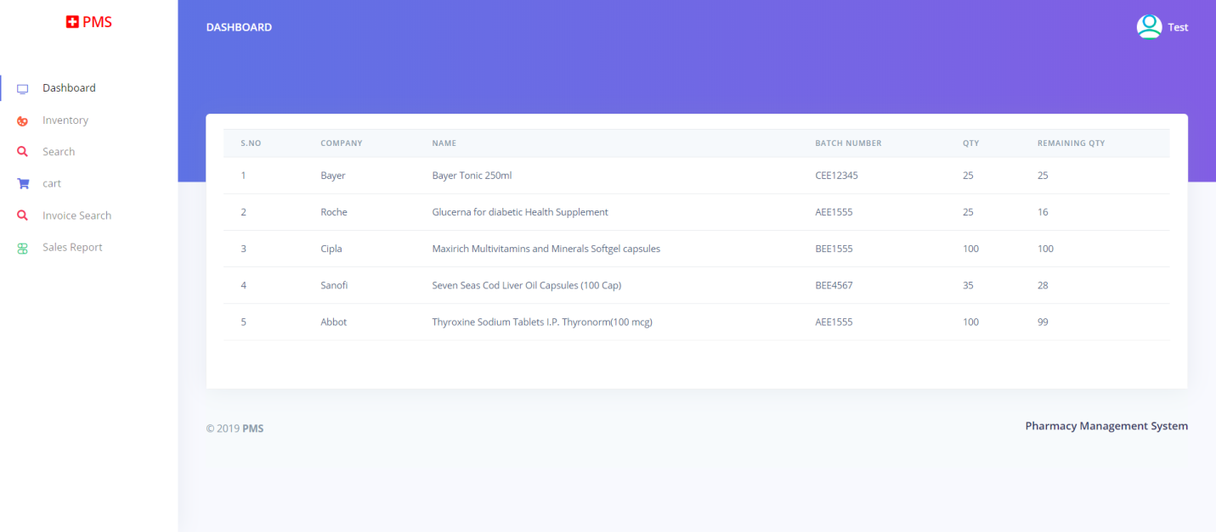

**Search Medicine**

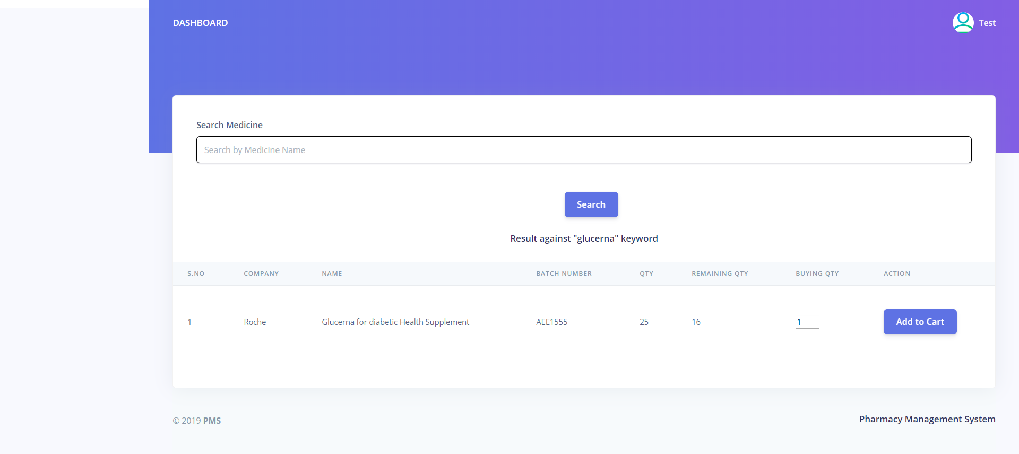

**Cart**

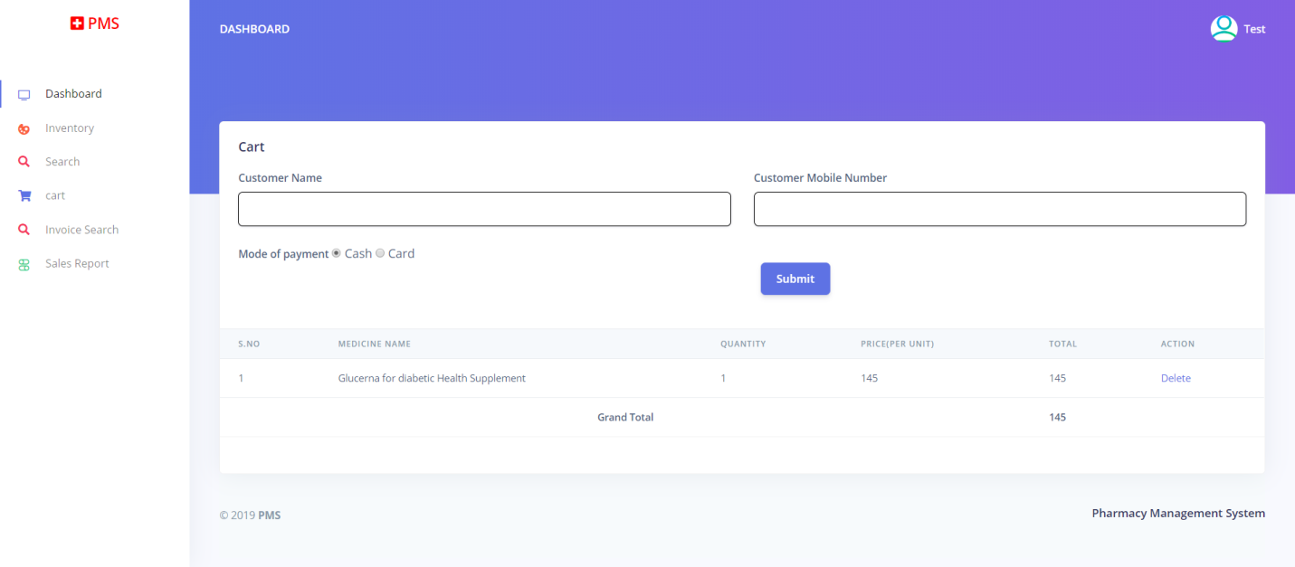

**Invoice Search**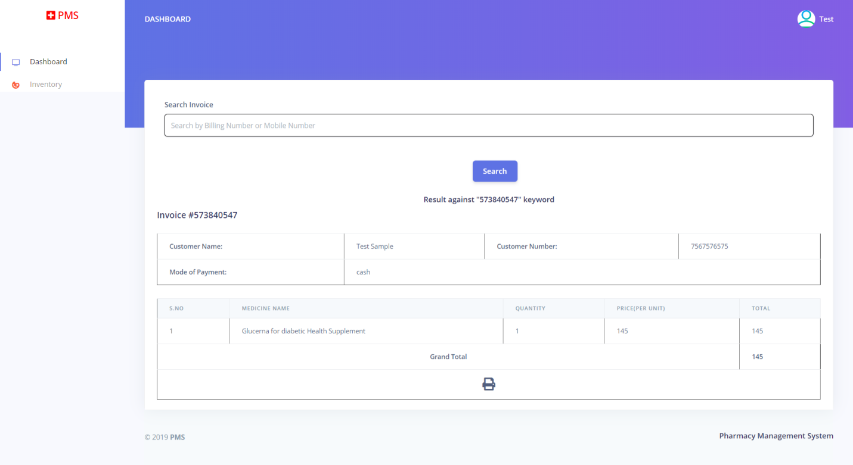

**Sold Report**

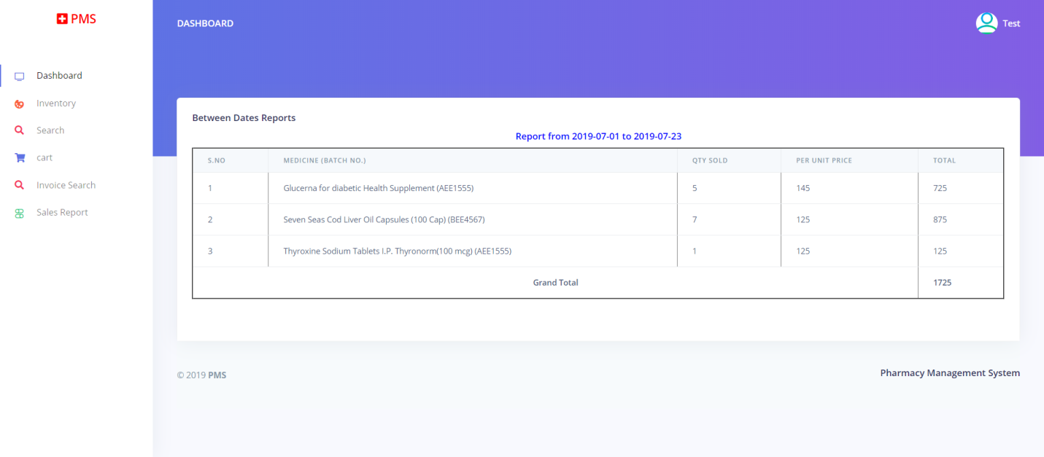

**Profile**

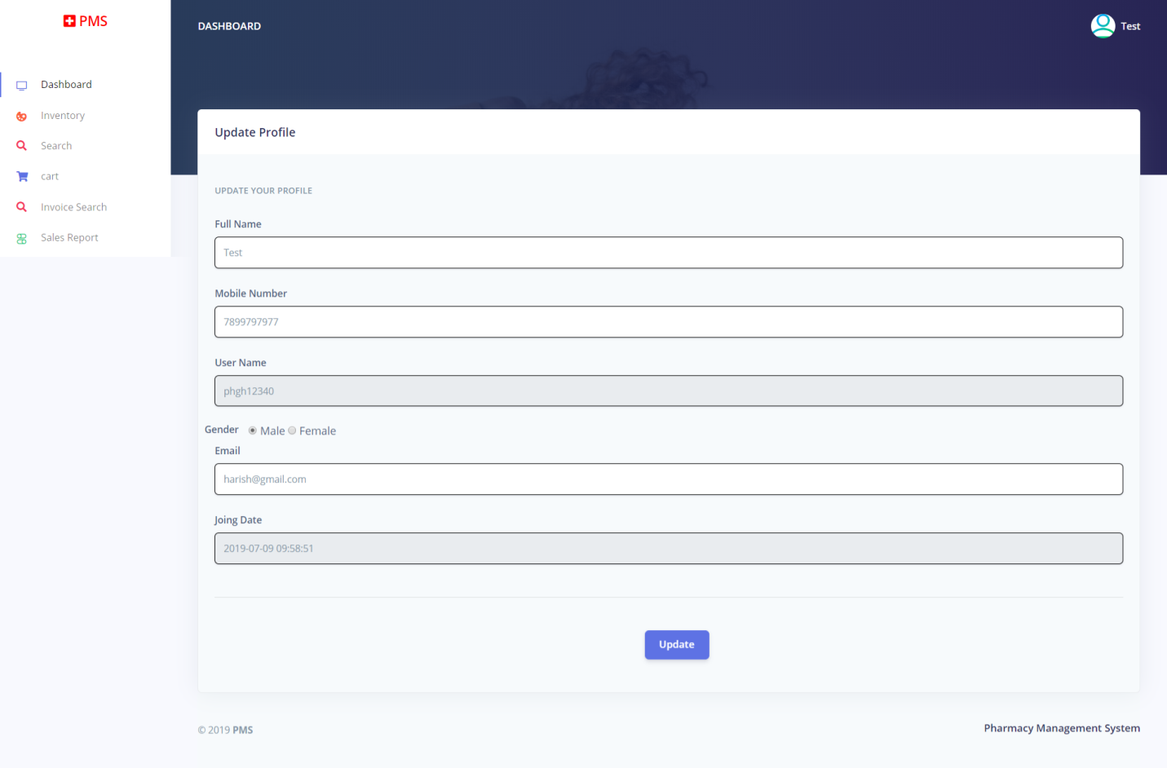

**Change Password**

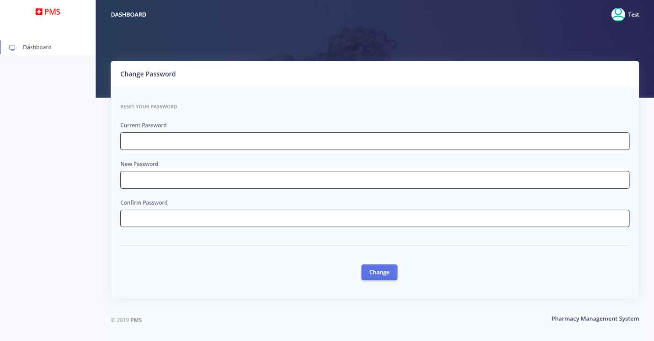

**Forgot Password**



**Reset Password**



**Conclusion**

Pharmacy management system is actually a software which handle the essential data and save the data and actually about the database of a pharmacy and its management. This software helps in effectively management of the pharmaceutical store or shop. It provides the statistics about medicine or drugs which are in stocks which data can also be updated and edited. It works as per the requirement of the user and have options accordingly. It allow user to enter manufacturing as well as the expiry date of medicine placing in stock and for sales transaction. This software also has ability to print reports and receipts etc. There is other function available too. The main purpose is effectively and easily handling of pharmacy data and its management

**9.2** **Recommendations**

Designing this application (Pharmacy management system) is not an easy task. It all started from the requirement gathering and passes through so many other stages before completion. Based on the benefits of this system and tremendous value it will add to customer-user satisfaction, the below recommendation will be considered; It is recommended that the new system should be used with the necessary specifications of the system requirements and provision for an uninterrupted power supply should be made available throughout the hours of operation of the pharmacy to avoid power outage. There should also be basic computer knowledge for the users of the software. It is recommended that the software be improved especially in areas of accounting as it will be of great impact to the development of retail pharmacy.

**9.3** **Limitations**

A number of limitations were encountered in the course of preparing this research work. One of such was in the creation of the tables in the database of the system. Due to the size of the system, many tables had to be created to accommodate all the data required in the management system. Also, implementing security features on the system was among of challenges to make sure that people will not be able to access information without authorisation from system administrator and to insure user are using unique password and using a strong password not less than five numbers.

**Bibliography**

For PHP

<https://www.w3schools.com/php/default.asp>

<https://www.sitepoint.com/php/>

<https://www.php.net/>

For MySQL

<https://www.mysql.com/>

[http://www.mysqltutorial.org](http://www.mysqltutorial.org/)

For XAMPP

<https://www.apachefriends.org/download.html>